30.62: (a) The voltage behaves the same as the current. Since 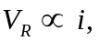the scope must be across the 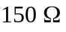resistor.
(b) From the graph, as 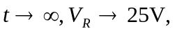so there is no voltage drop across the inductor, so its internal resistance must be zero.
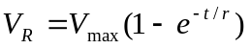
when 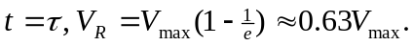From the graph, when 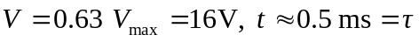
(c) Scope across the inductor:
